Calculating Family Expenses Using Service Now

**Problem Statement**

In a project of managing family expenses is often challenging due to the lack of a centralization system for tracking income,excpenses, and savings.Families typically rely on manual methods such as spreadsheet,paper records,or multiple apps,which can lead to errors,duplication,and difficulty in analyzing financial patterns.

**Objective**

**Simplify Expense Tracking**- provide a centralization system for recording and categorizing all family expenses

**Improve Financial Awarness-**offer real-time dashboards and reports to give clear insights into spending patterns

**Enhance Budget Planning-**support better financial planning by identify high-spending categories and opportunities to save

**Skills: Servicenow Development, Workflow&Automation, Scripting in Servicenow,Reporting&Dashboards, Integration Skills**

**TASK INITIATION**

## Update

**Activity 1:**

1.Open Service now

2.Go to All>>search for Local Update Set>Click on New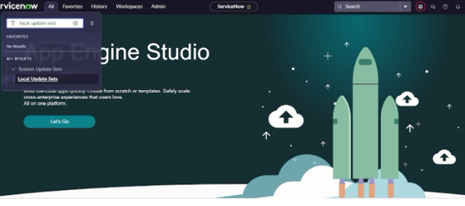

3.Enter the Details as:

Name:Family Expenses

4.And then click on Submit and make current

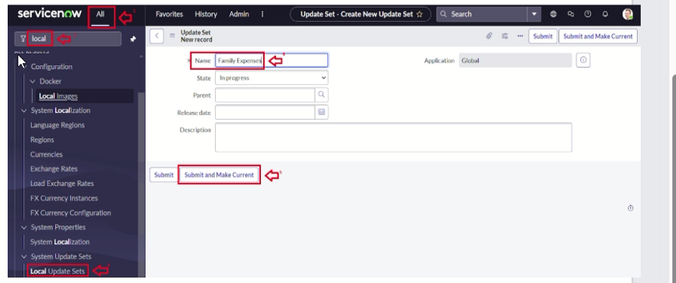

## **Table**

Activity 2:

1.Open Service now

2.Go to all>search for Tables>Click on New

3.Enter the Details:

Label:Family Expenses

Name:Auto-Populated

New menu name:Family Expenditure

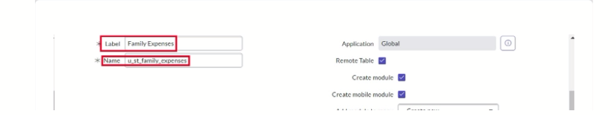

4.Click on save

Activity 2:

1.Open Service now

2.Near Columns Doubl;e Click near insert a new row

Give the details as:

Column label:Number

Type:String

3.Double click on insert a new row again

Give the details as:

Column label:Date

Type:Date

4.Double click on insert a new row again

Give the details as:

Column label:Amount

Type:Integer

5 .Double click on insert a new row again

Give the details as:

Column label:Expense Details

Type:String

Max length:800

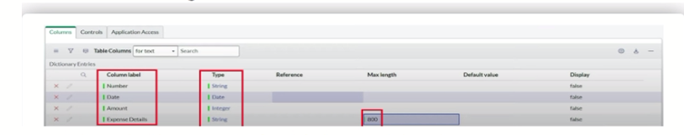

6.Click on save

Activity 2:

1.Open Service now

2.Double click on the Number field/Column

3.Go down and double click on Advanced view

4.In Default Value:

Use dynamic default:check the box

Dynamic default value:Get Next Padded Number

5.click on update

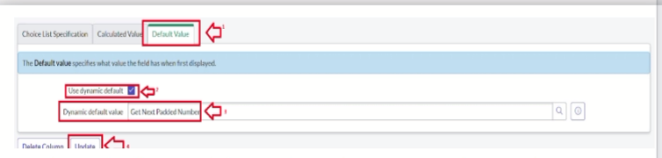

6.Go to all>>search for Number Maintenance>>select number maintenance

7.click on new

8.Enter the details:

Table:Family Expenses

Prefix:MFE

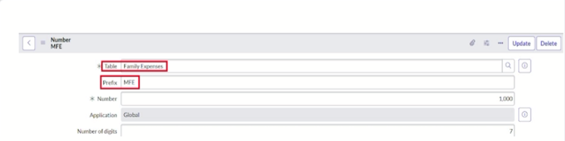

8.Click on Submit

Activity 2:

1.Open Service now

2.Go to all>>search for Family Expenses>>Open family Expenses

3.Click on new

4.Go to header and click there>>click on configure>>Select Form Design

5.Drag Drop the form as requirement

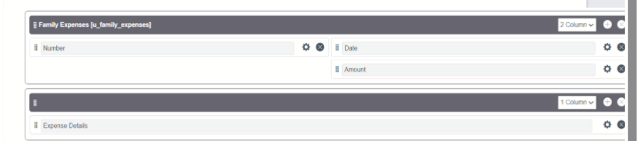

6.Make Number Read-Only Field by Clicking

7.Make Date,Amount Mandatory field by Clicking

8.Click on save

## Table(Daily Expenses)

Activity 3

1. 1.Open Service now

2.Go to all>search for Tables>Click on New

3.Enter the Details:

Label:Daily Expenses

Name:Auto-Populated

Add Module to menu :Family Expenditure

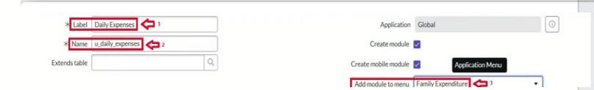

4.click on save

Activity 3:

1.Open Service now

2.Near Columns Doubl;e Click near insert a new row

Give the details as:

Column label:Number

Type:String

3.Double click on insert a new row again

Give the details as:

Column label:Date

Type:Date

4. Double click on insert a new row again

Column label:Amount

Type:Integer

5 .Double click on insert a new row again

Column label:Expense Details

Type:String

Max length:800

6.Double click on insert a new row again

Give the details as:

Column label:Comments

Type:String

Max length:800

6.Click on save

Activity 3:

1.Open Service now

2.Double click on the Number field/Column

3.Go down and double click on Advanced view

4.In Default Value:

Use dynamic default:check the box

Dynamic default value:Get Next Padded Number

5.click on update

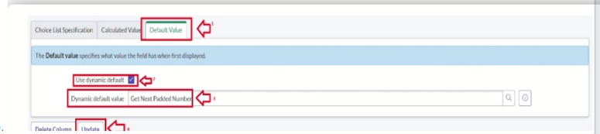

6.Go to all>>search for Number Maintenance>>select number maintenance

7.click on new

8.Enter the details:

Table:Daily Expenses

Prefix:MFE

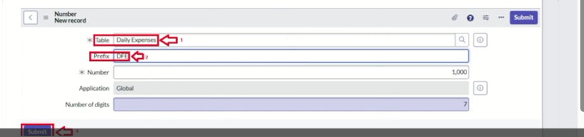

9.click on submit

Activity 3:

1.Open Service now

2.Go to all>>search for Daily Expenses>>Open Daily Expenses

3.Click on new

4.Go to header and click there>>click on configure>>Select Form Design

5.Drag Drop the form as requirement

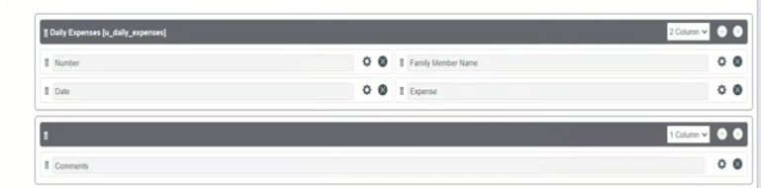

6.Make Number Read-Only Field by Clicking

7.Make Date,Family Member Name Mandatory field by Clicking

8.Click on save

## Relationship

Activity 4:

1.Open Service now

2.Go to all>>search for relationships>>open relationships

3.click on new

4.Enter the details:

Name:Daily Expenses

Applies to table:select Family Expenses

Daily Expenses:select Daily Expenses

5.click save

## Configuring Related List

Activity 5:

1.open Service now

2. .Go to all>>search for Family Expenses>>Open FamilyExpenses

3.Click on new

4.Go to header and click there>>click on configure>>select Related Lists

5.Add Daily Expenses to selected area

6.click on save

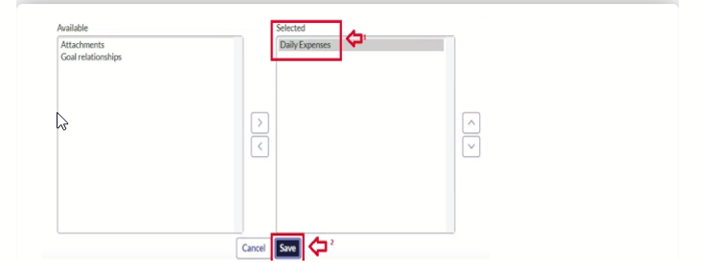

## Business rule

Activity 6:

1.Open Service Now

2.Go to all>>search for Business Rules

3.Under system definition select business rules then click new

4.Enter the Details:

Name:Family Expenses BR

Table:Select Daily Expenses

Check Advanced

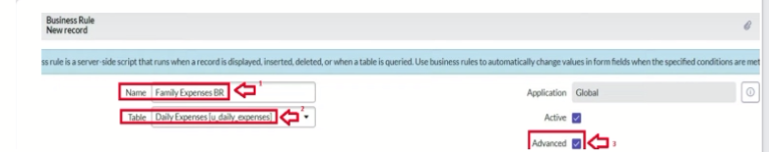

5.In when the run check insert and update

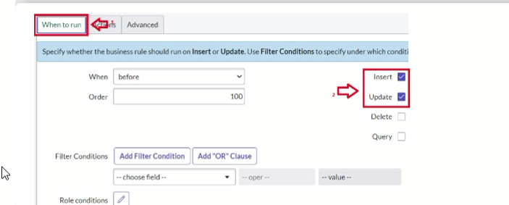

6.In Advance(we write the code)

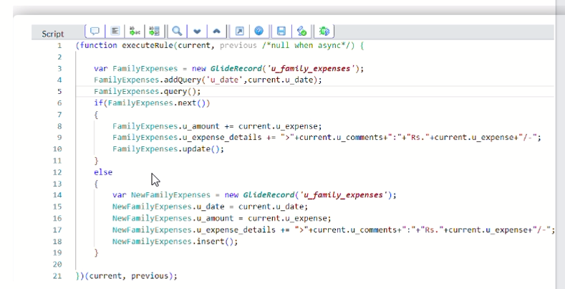

7.click on save

## Configure The Relationship

Activity 7:

1.Open Service now

2.Go to all>>search for relationships>>open relationships

3.In open Daily Expenses relationship

For Applies to table:select Family Expenses

In Query with:write the below Query

4.click on update

## 